UDAY SHANKAR

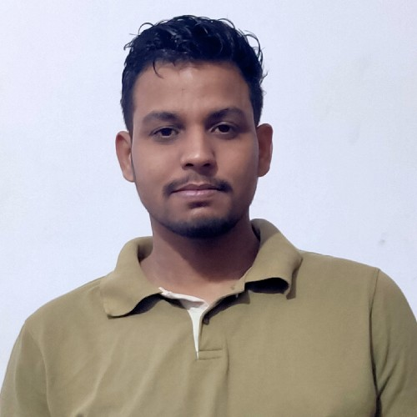 [uday.r](mailto:uday.rockx868@gmail.com)[ockx868@gmail.com](mailto:ockx868@gmail.com)

 (+91)9336119628,9721198977

 Q.No-1264/A Manasnagar Colony, Mughalsarai,Chandauli,U.P

To enhance my professional skills, capabilities and knowledge in an organization which recognizes the value of hard work and trusts me with responsibilities and challenges.

*24/06/2019 -*

*20/07/2019*

Trainee



Escorts Training & Development Center (Bangalore,Karnataka)

Learning all things about Tractor. Handling Tractor equipments.

Learning about different parts of tractor.

Learning about the sales department of company. Learning about the Testing of Tractor.

*2020*

*2015*

*2013*



B.Tech(Agriculture) 6.61(CGPA)



HSC(Physics, Chemistry, Mathematics)(Major) 61.3%



SSC

9.0(CGPA)



B.Tech Project

Performance evaluation of manually operated onion bulb planter with half seed hopper.



Escorts Project

Installation of care device in Tractor and learning about sales department of company.

Food & Agriculture Fest- IIT Kharagpur Food & Agriculture Conference- SHUATS



Participated in All India Inter Agricultural Universities Sports & Games Meet 2018-19. Participated in National Science Exhibition.

Participated in scouts and guide.

2nd position in Poster presentation- Food & Agriculture Fest IIT KHARAGPUR 1st postion in Interhouse kabbadi tournament - SHUATS

Basic Elementry Training in Auto CAD Sales

MS OFFICE:- Excel,Word,Power Point Presentation Highly motivated and quick learner

Team Building

Flexibility and Adaptability

DateofBirth :03/03/1998

Nationality :Indian

Sex :Male

Father'sName : Arun Kumar Singh Language proﬁciency : Hindi &English

Sports : Kabbadi,Football

Hobbies : Singing,Cooking